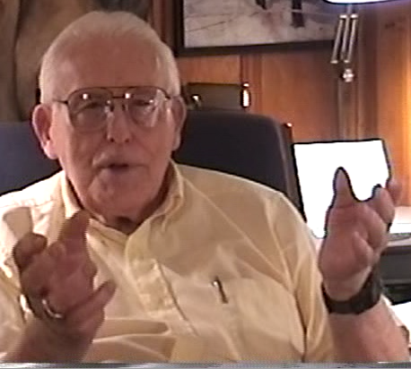
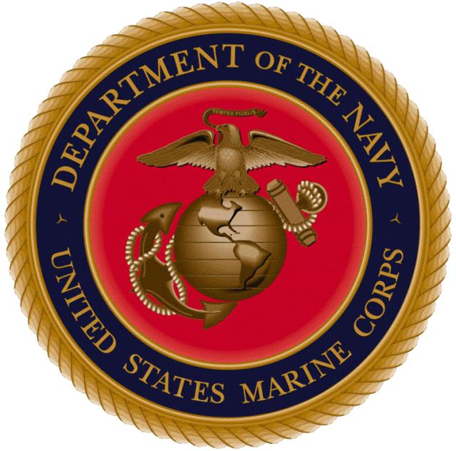
NORM HATCH
U.S. MARINE
&
ACE PHOTOGRAPHER
(1921-)

DID NOT START A MARINE
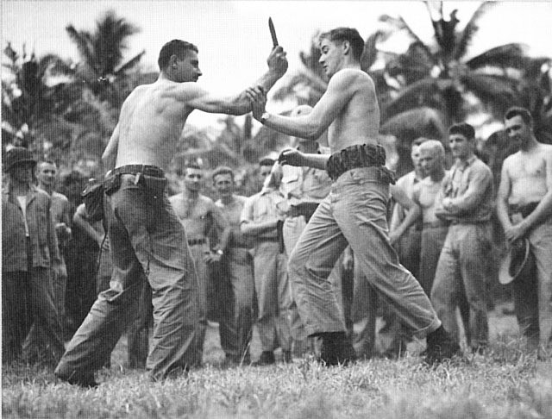
“First I was accepted by the Navy they took very few people at this time. I had to wait for free the spots, I went back to the office all the time to check availibility. In the middle of June 1939, that was the last time I went to the office. The Service provided food and shelter to the veterans they only took five at time, in all of New England. I then went to the Marine corps and asked when they would take me, they said two weeks from the friday. I joined up in 1939. When in the Marines I was a rifleman, I was in bootcamp, I had three years of ROTC so I had no problem in marching and details. I was going to be assigned to Sea School due to my hight, I knew what it was like to board a ship. While on the ship I saw on a board, they needed an instuctor for the Marine corps institute in English, two weeks later my Drill Instructor asked me what the hell I was doing, I got the job and was sent back to Washington DC.”

A DATE WHICH WILL LIVE IN INFAMY
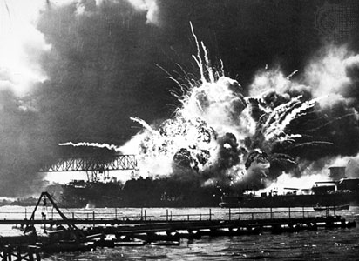
“When Pearl Harbor was attacked I was in New York I was sleeping in. I had the radio set to begin at 10 and I heard in his sleep about an attack but I did not think it was real I then heard “all Service men report to your commands”. I was assigned to paperwork detail and I heard all about the bombing and the call. I called the Sergent Major asked if I needed to come in I was told “Hatch stay put”. Then I was called to go to Washington to film the declaration of war made by Roosevelt so I drove down with all the gear the Camera crews were getting set up in the front row of seats there was no room with the camera present. I took care of all the news reels when working with film. Then I was transferred to Quantico then I was sent to the 2nd division in San Diego Spent 11 months in New Zealand, I trained there and got ready to practice landings.”

ISLAND OF TARAWA
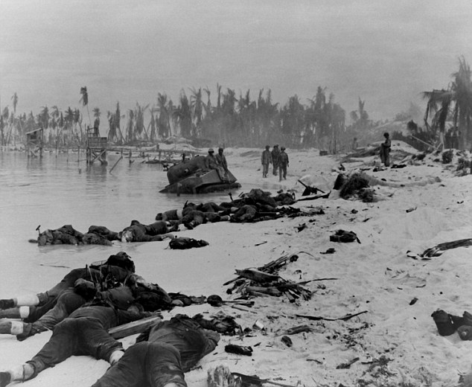
“I sat on the engine to get pictures. I was shooting the visuals when we hit a reef the ramp would not work the men had to go over the Gunwales of the boat. We had four canisters, four or five reels, we held up the cameras when walking onto the beach. The Major was upset at losing the beach front this is why I was in the First wave. Another major was already on Shore seeing the loss of beach head caused us to move in, I was carrying about 70 pounds of gear when I got into the water All the guys dog paddled to get to beach like a hurd of Turtles. When we got to the beach I was tired if there had been a Bonzai Charge we would have been killed. It took 76 hours to take the island when the Japanese commander said it would take 100 years to take the island.”

PHOTOS FROM IWO JIMA
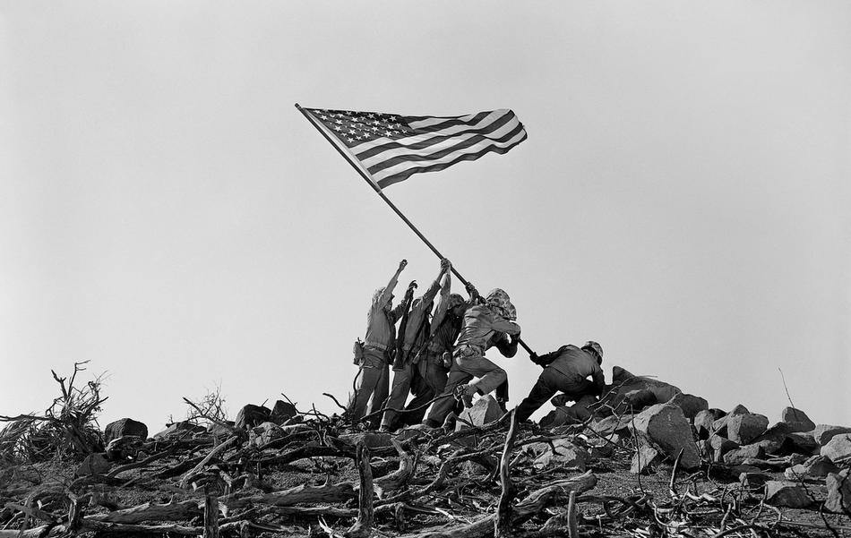
“We then arrived at Iwo Jima the most important island. mayor of the Tokyo was commanding the island, the terrain looked desolate like the moon, lots of Volcanic ash. I went to shore on the first day, I went to the intellegence command post and I found a gun mount with he placed a tarp over and this was the intellegence post. I had to make sure all the cameras were working well, these are the kind of operation that went on. When I got word the second flag was being placed upon the mountain the Generals ordered me to get photographers down their 20 minutes later they tell me the photographers found good shots. I told them to gat back to Saribachi, since the brass wanted a bigger flag the men ran into Rosenthal they joked a bit and they all shot photos of the flag being raised. my men are just as responsible for the photo as Rosenthal was. If the picture was it's original it would not have been as well liked it was edited to look better and they say the edited picture was the original.”

